**Entertainer Analysis**

Architecture Design

|  |  |
| --- | --- |
| Written by | Author 1 |
| Document Version | 0.1 |
| Last Revised Date |  |
|  |  |

Document Control

Change Record:

|  |  |  |  |
| --- | --- | --- | --- |
| Version | Date | Author | Comments |
|  |  |  |  |
|  |  |  |  |
|  |  |  |  |
|  |  |  |  |

Reviews:

|  |  |  |  |
| --- | --- | --- | --- |
| Version | Date | Reviewer | Comments |
|  |  |  |  |

Approval Status:

|  |  |  |  |  |
| --- | --- | --- | --- | --- |
| Version | Review Date | Reviewed By | Approved By | Comments |
|  |  |  |  |  |

Contents:

1. Introduction……………………………………………………..4

1.1 What is Architecture Design Document………………………4

1.2 Scope…………………………………………………………..4-5

2. Architecture…………………………………………………….6

2.1 Power Bi Architecture…………………………………………6

2.2 Power Bi service architecture………………………………….7

2.3 Background and Communication flow………………………..7

3. Deployment……………………………………………………..8

3.1 Deployment options in Power Bi………………………………8

3.2 Features and Products………………………………………9-10

**1. Introduction:**

Power Bi is a collection of apps and services which are integrated together to derive insights from the sources of the data like database, excel , csv , text , web and etc.

Power Bi is used for:

1. Making interactive dashboards

2. customize the actions and interface for making the look and feel of the dashboard.

3. Easy to make operations and measures.

1.1 What is Architecture Design Document

The architecture design document is a technical document which describes the specifications and components for the project and it is used to determine the scope of project in terms of technical and business requirement.

* Includes conceptual , logical and physical design
* Describes the approach for the solution
* Describes the technical specifications for the business requirement.
* Logical description of the components for the project.

1.2 Scope

The scope of the project is:

Problem Statement:

Normal life can be stressful, and people need to relax. Being entertained by others

is a wonderful way to take some time out of life. It can reduce stress and make life's

issues easier to face. The media and entertainment industry consists of film,

television, radio and print. These segments include movies, TV shows, radio shows,

news, music, newspapers, magazines, and books. Entertainment industry is a group of

sub-industries devoted to entertainment. Entertainment industry is used to describe the

mass media companies that control the distribution and manufacture of mass

media entertainment.

Task #1 - In a word document write the process and data added to the current dataset.

In addition, mention the theme on which you will be creating the dashboard.

Task #2 - You can add your data as per your convenience.

Task #3 – Do the data preparation part.

Task #4 – Build the dashboards

Task #5 – Build a Storyline

Desired approach:

1. To perform Extract transform load in the dataset

2. Fetch and transform the dataset

3. Prepare the Dataset

4. Perform datamining operations

5. Visualize the results

6. Create the dashboards.

**2. Architecture**

2.1 Power Bi Architecture

Power BI architecture is built on Azure. Multiple data sources are supported by Power BI. Power BI desktop is used to create interactive reports and stunning dashboards on the dataset. Power BI gateway is connected to on premises data sources for continuous data for reports and analysis.

Power Bi service is the cloud service which is used to publish the reports and dashboards to the web.

Power BI is supported over Android, iOS, windows platforms.

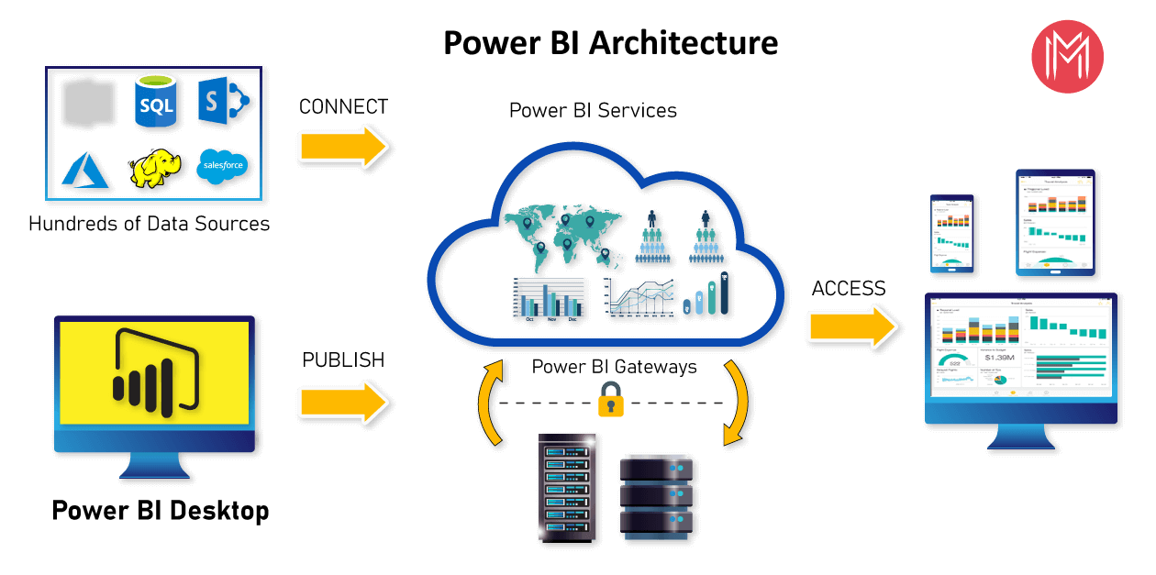

Advantages:

1. Access to volumes of data from varied sources

2. Interactive features and visuals to create reports and dashboards

3. Real time analytics

4. Actionable insights and visuals.

2.2 Power Bi service architecture

Power BI service is the software as a service which is the part of Power BI.

* It allows to connect data and to create reports and dashboards

2.3 Background and Communication flow

Components of Power BI

1. Power Query

- Data transformation engine which is used to discover , connect , combine and refine the data.

- Which is used to transform the data.

2. Power Pivot

- Data modelling technique which is used to create models, relationships and to perform calculations.

3. Power view

- available in excel , sharepoint , SQL server and Power BI

-Used to create interactive charts , graphs

- Used to filter data for the visuals

4. Power map

- 3D visualization tool which is used to create map of the data and plot million rows of data visually on Bing maps in 3d format.

- Used to give the latitude , longitude, country , city , state etc.

5. Power BI desktop

- Used for power query , power view , power pivot for developing and driving analysis and insights from the data.

6. Power Q&A

- Used to explore the data

- Used to give more insights from the data.

M formula language:

* The power query is used to filter and combine the data from varied data sources.
* The power query operations are performed by use of M query language.
* It is functional and case sensitive.

**3. Deployment**

3.1 Deployment options in Power Bi

There are varied deployment models:

1. On premises: Refers to data applications and infrastructure which is owned by client data center and client has control over it.

2. Cloud: Refers to data applications and infrastructure in public cloud environment.

3. Hybrid: Combination of both on premises and cloud.

Power BI supports all 3 types of models.

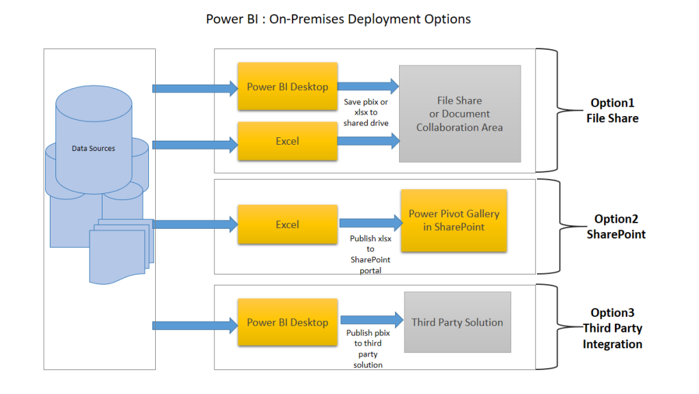

On premises deployment:

1. File share:

- Data preparation and reports are in the client machine or tools like Power BI desktop.

2. Sharepoint

-Data preparation and report creation in excel

- Excel file is published to sharepoint.

3. Third party integration

- Data preparation and reports are in Power BI desktop.

- The file is shared and published with the third party servers.

Hybrid Deployment

1. Power BI service:

- Data preparation and reports are in Power BI desktop.

- Reports and dashboards are published in Power BI server

2. Custom Application Integration

-Data preparation and reports are in Power BI desktop.

- Reports and dashboards are published in Power BI server

- With the use of Power BI API these reports can be published in web applications using iframe

3. Public Website

- Data preparation and reports are in Power BI desktop.

- Reports and dashboards are published in Power BI server

- The reports can be embedded by using iframe.

3.2 Features and Products

Features:

* Interactive visuals
* Supports varied data sources
* Power Q-A to explore more about the data
* Easy to use filters
* Actionable insights
* Easy to integrate

Products:

Power BI desktop

- Used for power query , power view , power pivot for developing and driving analysis and insights from the data.

- Used to create reports and stunning dashboards

Power BI service:

- Data preparation and reports are in Power BI desktop.

- Reports and dashboards are published in Power BI server

Power BI dashboard:

* Used to insights data from the dataset
* Used to generate dashboards from the reports
* Single page dashboard is known as canvas
* Reports can be published to Power BI dashboard using Power BI service.
* The visuals in the reports are known as tiles.